We have recently started using PKSubmit and are facing some problems for importing the data. In our lab, the usual procedure is the following: we import the data from Watson LIMS and then perform the NCA by means of Phoenix. In case we want to create the PC file using PK Submit, we would like to take the concentrations directly from the project that has been already created. The Watson-Phoenix interface works properly, but when we try to generate the PC domain:
we cannot choose the data From a Phoenix Project (this option is missing in the screen):
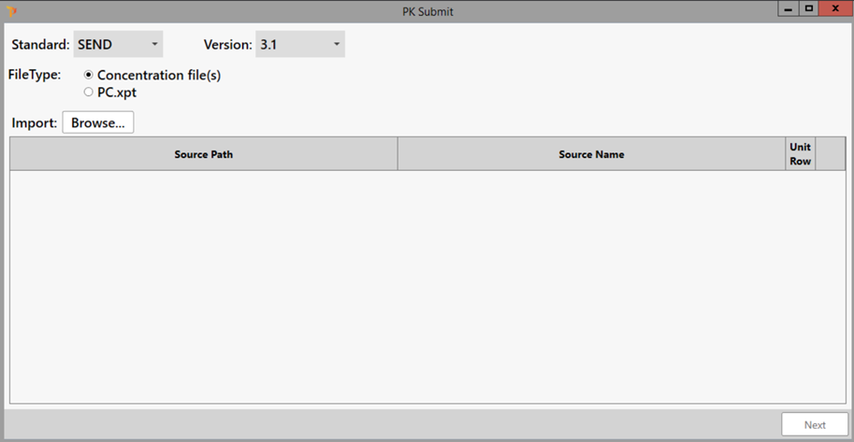
Could this be related to any study configuration issue?
Thanks
Xavier

