Right-click to add a new observation.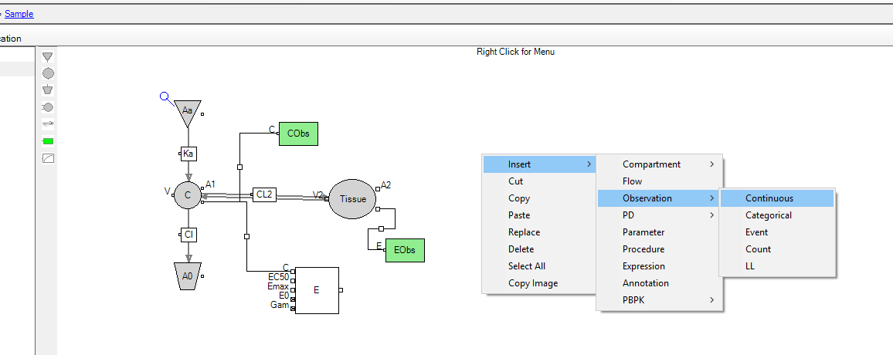

Rename it appropriately in the bottom panel

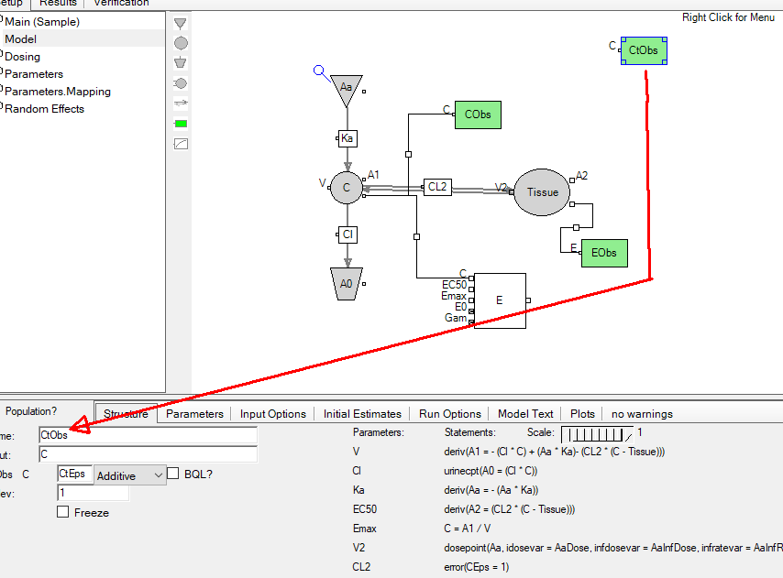

Lastly drag from bottom right node to link to your new observation

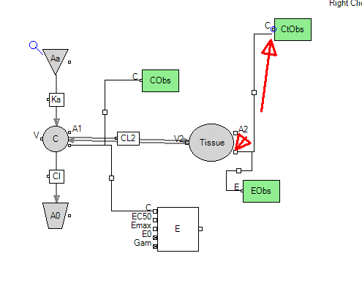
However I would mention that I don’t think you necessarily have 2 com kinetics for your plasma conc so you may have to re-think your approach.

