Hi Simon. the issue is because if you don't explicitly state the administered dose (that which generated the initial concentrations), then the first dose is assumed to be that dose.

Hence you were getting a difference between loading at 400 and 800 mg. see my attached project where admin was set to 400mg for both

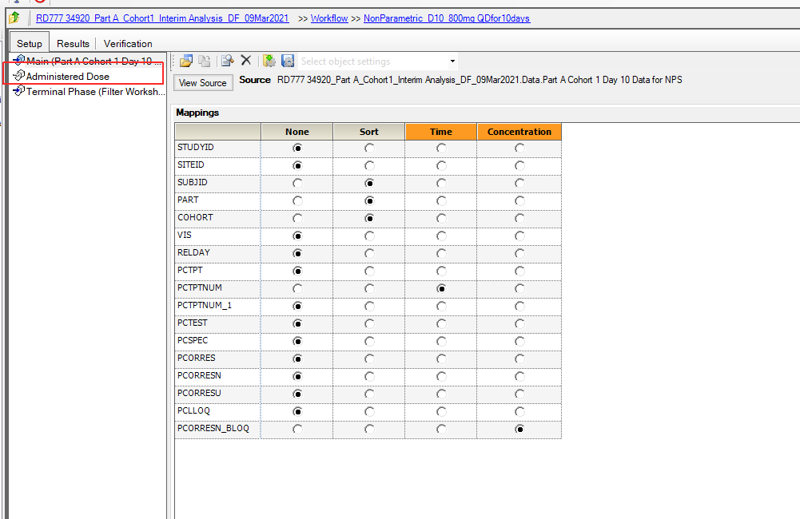

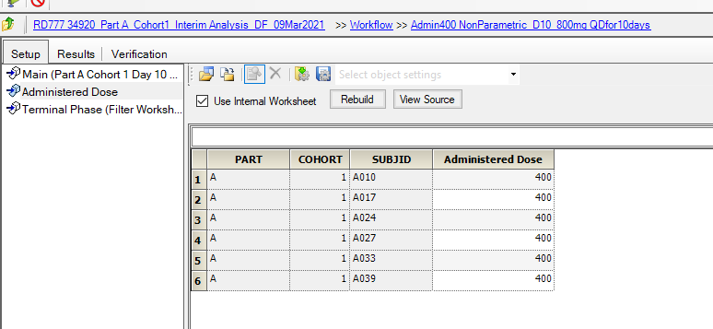

and give identical profiles at steady state.

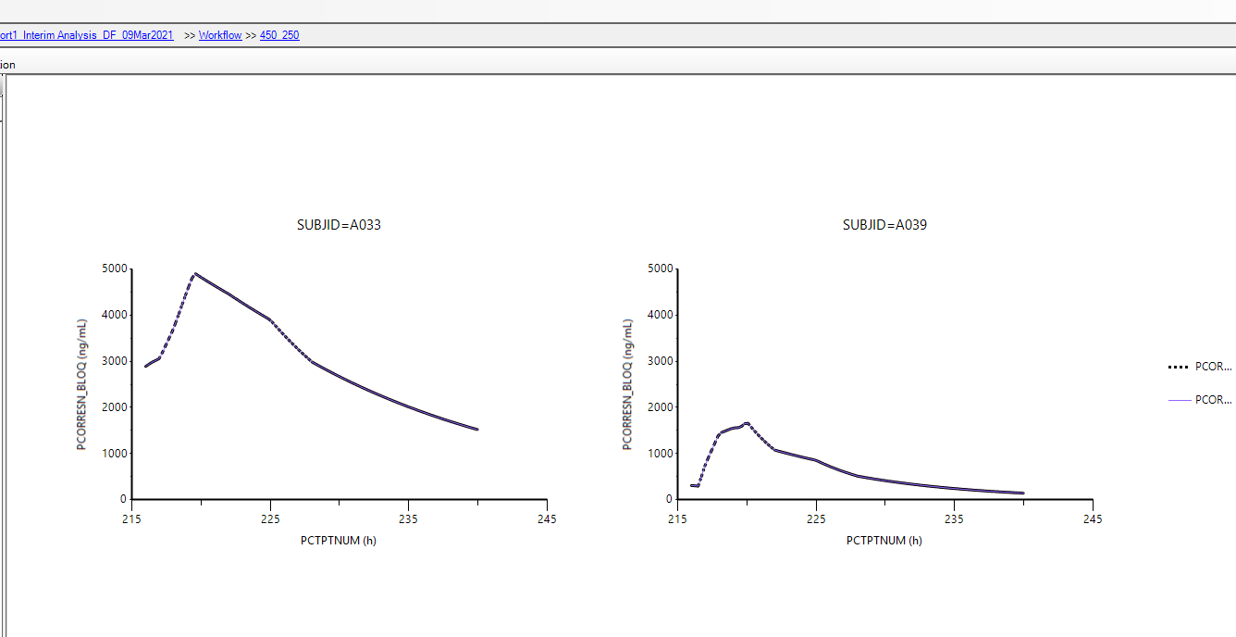

the lesson in my opinion is to always explicitly state the original (administered) dose.  the accumulation plot hopefully makes this clearer

