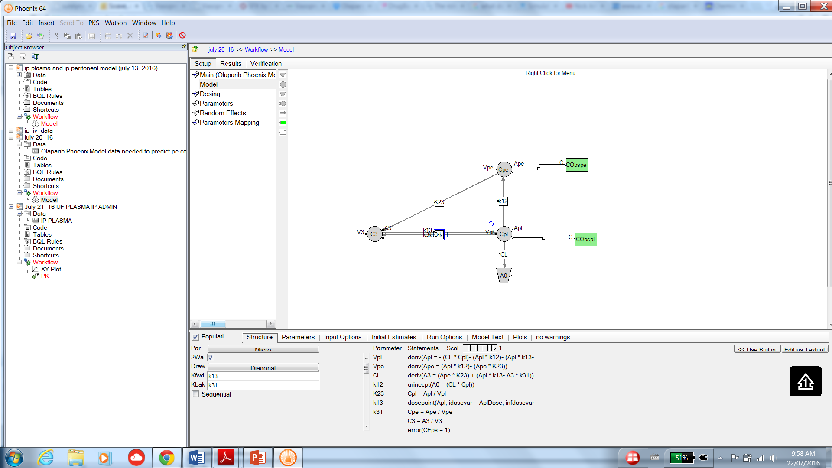

Data available

What we want to have model predict

-Drug is orally administered, 400 mg BID

-Enters plasma (central compartment)